

October 2021
Devon & Somerset
Fire & Rescue Service
Diversity & Inclusion and HR Services
Gender Pay Gap Report
2021

Table of Contents
Foreword 3
1. Introduction 4
2. Methodology 5
2.1 Pay within the Service 5
2.2 Employees’ working hours 5
2.3 Hourly Pay 7
2.4 Bonus pay 7
2.5 Other exclusions from the calculation 7
3. Results and key issues 7
3.1 Gender Pay Gap 7
3.2 Pay by quartiles: hourly pay quartiles 8
3.3 Key issues 9
4. Where is the Gap coming from? 9
4.1 General factors influencing an organisational Gender Pay Gap 9
4.2 Equal Pay 10
4.3 Occupational Segregation in the Service 10
Wholetime 11
On Call 11
Control 12
Green Book staff 13
Casual Workers 13
Conclusion about the effect of occupational segregation on the gender pay gap 14
4.4 Flexible working in the Service 14
5 Ethnicity Pay Gap 16
5.1 Methodology 16
5.2 Ethnicity Pay Gap within the Service 17
5.3 Where does the ethnicity pay gap in the Service come from? 18
6 Working towards reducing the Gender Pay Gap 19
References 20
Appendix – Figures, tables and charts 21
Gender pay gap 21
Gender pay gap Quartiles 22
Ethnicity Pay Gap 23
Ethnicity pay gap Quartiles 23

Devon & Somerset Gender Pay Gap Report
Devon & Somerset Fire & Rescue Service Gender Pay Report

Foreword
Devon and Somerset Fire and Rescue Service (the Service) believe in equal treatment for all and this includes equal employment opportunities and equal treatment for all employees within the Service. The Service is an equal pay employer based upon recent measurement of men and women in the same employment, performing equal work, with equal responsibilities, receiving equal pay using nationally established pay scales (‘Grey book’, ‘Gold book’ and ‘Green book’) as identified within our Equal Pay Audit 2017.

The Service is working to actively reflect the communities we serve in all areas of inclusion and diversity. However, more work remains to be done to ensure equality for all, to increase the number of uniformed female staff from the current 6% of roles, to establish a gender balance at senior management levels and to ensure that the Service fully reflects the communities it serves. This report sets out a calculation of average difference in pay between male and female employees and sections 4 and 5 (‘Where is the Gap coming from?’ and ‘Action Plan to Reduce Gender Pay Gap’) demonstrate that the Service is committed to doing everything possible to understand, reduce and eradicate the Gender Pay Gap.

The data included within our Gender Pay Gap Report has been calculated in accordance with the requirements of the Equality Act 2010 (Specific Duties and Public Authorities) Regulations 2017.

Lee Howell
Chief Fire Officer


1. Introduction

Legislation, in force since April 2017, in relation to the Equality Act 2010 (Gender Pay Gap Information, Specific Duties and Public Authorities) requires employers with 250 or more employees to publish statutory calculations every year showing how large the pay gap is between their male and female employees. Reports are required to be on the employer’s website for 3 years.
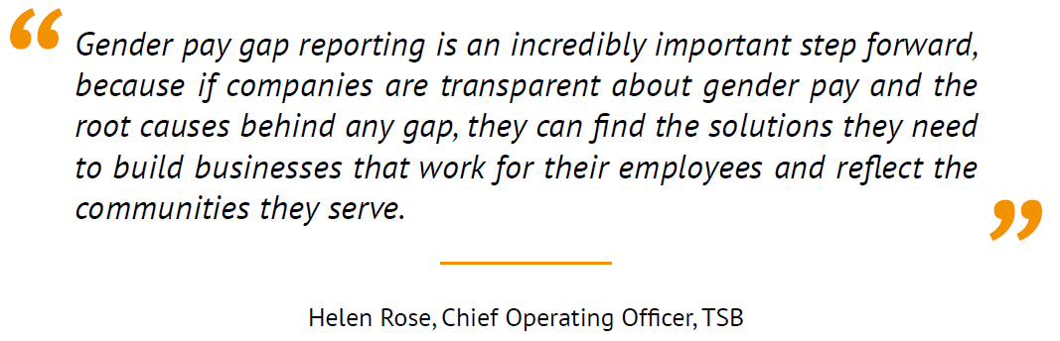

The pay gap is the percentage difference between average hourly earnings for male staff and female staff. There are six calculations and the results must be published on the Devon & Somerset Fire & Rescue Service (“the Service”) website and a government website within 12 months of the data point (31 March each year). The calculations are:

Mean gender pay gap | The difference between the mean hourly rate of pay of male  employees and that of female employees as a percentage of the male mean hourly rate.
Median gender pay gap | The difference between the median hourly rate of pay of male employees and that of female employees as a percentage of the male median hourly rate.
Mean bonus gap | The difference between the mean bonus pay paid to male employees and that paid to female employees as a percentage of the male mean bonus.
Median bonus gap | The difference between the median bonus pay paid to male employees and that paid to female employees as a percentage of the male median bonus.
Bonus proportions | The proportions of male and female relevant employees who were paid a bonus during the relevant period.
Quartile pay bands | The proportions of male and female employees in the lower, lower middle, upper middle and upper quartile pay bands.

2. Methodology

2.1 Pay within the Service
In the UK, various nationally agreed schemes of pay and conditions apply to all Fire and Rescue Services. There are the following categories of staff terms and conditions within the Service:

Uniformed Staff: This includes Whole-time and On-call staff and also the Control Room uniformed staff. The remuneration levels for these staff are subject to national negotiation as contained in the Scheme of Conditions of Service of the National Joint Council for Local Authority Fire & Rescue Services which is known as the “Grey Book”. Any other remuneration is subject to local agreement.

Support Staff: This category is the non-uniformed employees who support our Operational Service. The Scheme of Conditions of Service for these employees is set out within the National Joint Council for Local Government Services known as the ”Green Book”.

Executive Board Officers (including Chief Fire Officer): The Executive Board is a mix of uniformed Brigade Managers and non-uniformed Officers who are the Directors of the Service. The salary structure for Brigade Managers and other Executive Board members has previously been determined by the Authority and is subject to annual reviews in accordance with the Constitution and Scheme of Conditions of Service of the National Joint Council for Brigade Managers of Local Authorities’ Fire Brigades which is known as the “Gold Book”.

Grey Book posts within the Service are classified according to national role maps, in line with guidance contained in various circulars published by the National Joint Council for Local Authority Fire & Rescue Services. Green Book posts are evaluated using the Greater London Provincial Council Job Evaluation Scheme which was specifically designed for local authorities.

The job evaluation scheme for Green Book employees and national role maps for Grey Book employees provide assurance within the pay scales, i.e. male and female staff are paid equally for the work they do within the scales and within national conditions of service.

Through undertaking a regular Equal Pay Audit, we are confident that male and female staff are paid equally for the work they do under the nationally approved (and union agreed) systems. Consequently, the emphasis in this report is on an analysis of the number of male and female staff in various categories who are in particular salary grades.

2.2 Employees’ working hours
As part of the Grey Book, On-call Firefighters, i.e. those who respond from home or primary employment or from the local vicinity of the Fire Station, are paid an On-call fee or ‘Retainer’ fee which 10% of the full-time basic annual salary. This Retainer is for the staff to be available to attend emergency incidents occurring within agreed periods of the week. When attending emergency incidents or training then they are remunerated with an hourly rate of pay in accordance with the role they performed and at the same rate as Wholetime Firefighters who are full-time but have a shift working pattern.
Within The Equality Act 2010 (Specific Duties and Public Authorities) Regulations 2017, Schedule1, Section 7, Employee’s working hours in a week, paragraph (8) states:

(8) In this paragraph, “working hours”-
(a) includes hours when an employee is available, and required to be available, at or near a place of work for the purposes of working unless the employee is at home, and (b) excludes any hours for which an employee is entitled to overtime pay.

In considering this for our On-call staff who are available near to their station this will include hours when the employee is at home. However in Schedule 1, Section 2 Duty to publish annual information relating to pay, paragraph (3) states:

(3) In compiling the information required by sub-paragraph (1), a relevant public authority is not required to include data relating to a relevant employee if-
(a) the employee is employed under a contract personally to do work, and
(b) the public authority does not have, and it is not reasonably practicable for the public authority to obtain, the data.
In terms of On-call staff, the Service does not hold data on the location from where the employee is providing availability from i.e. whether it is in their home. For this reason, the Service has not included the Retainer as part of the calculation of On-call hourly pay for those staff which still operate on the Pay as you Go scheme.
As a replacement of the Pay as you Go scheme, at the end of 2020, the Service has started implementation of a new pay scheme for On Call staff; Pay for Availability (P4A). This scheme is different in that it does not pay a monthly ‘retainer’ fee, instead it pays a small amount for hourly availability. In view of the above rationale, all availability payments for the P4A stations have been excluded.
The Service also had 10 out of 70 On-call stations that were paid a salary based on historic levels of emergency incidents, some of which have been transitioning to P4A during the period this report covers. The salary includes an On-call Retainer fee but again, the Service does not hold data on the location from where the employee is providing availability and for this reason, these staff have not been included in the calculation of hourly pay.

Annual leave payments are also not included in the calculations as ‘daily’ rates are paid in relation to this, which include average P4A availability payments and, therefore, can’t be converted into an hourly rate for this purpose.
And finally, any other “overtime” paid just for providing cover, rather than for work, is not included.
The Service employs Flexi-duty Officers who are full-time employees but will respond to Emergency Incidents to provide Incident Command. This could be during normal business hours or during periods outside of the normal day i.e. evenings and weekends. For these staff, they receive a 20% allowance for providing positive working hours and standby cover. For the calculation of hourly pay, the 20% allowance has been included. The same principle has been used for other Support Staff who also provide standby cover. Area Managers are considered as working 42 hours a week rather than working to the flexi duty rota.
The Service has a Training Allowance paid for required additional hours and these hours are incorporated into the working hours.

2.3 Hourly Pay
All data for the purpose of the Gender Pay Gap calculations has been extracted from the HR system ‘Workforce’ and the payroll system ‘iTrent’. The data provided by the Service’s Human Resources Department was anonymised and analysed using Microsoft Excel. Data is correct as of 31/03/2021
Employees included in the calculations are Full Time workers, Part Time workers (with job sharers counting as two), Casual workers and Consultants, if they personally perform the work. Pay covers all elements of normal remuneration (i.e. sick pay, annual leave pay, maternity pay, flexible shift pay) and car allowance. Not included are benefits in kind e.g. child care vouchers and other salary sacrifice schemes, expenses, overtime and redundancy payments.
The Service has used a reference period of March for staff with normal working hours and anyone who was not employed for the whole of March or were on unpaid leave or maternity leave in the reference period have been excluded.
For On-call staff, where weekly hours can be variable, the pay and working hours are based on the average of a three month period, i.e. January-March, preceding the snapshot date. Any On-call staff who were not employed for the whole of January-March or were on unpaid leave or maternity leave in the reference period have been excluded. Any On-call staff whose derived “annualised” hours were less than 104, i.e. minimum annual hours for On-call staff, were also excluded.

2.4 Bonus pay
The Service does not offer a bonus scheme therefore this calculation has not been performed. Additional Responsibility Allowances (ARAs) and Continuous Professional Development (CPD) payments are included in ordinary pay.

2.5 Other exclusions from the calculation
Those members of staff who have identified as transgender or other gender fluent expressions and have not indicated whether they wish to be included in the male or female category for the purpose of these calculations, have also been excluded.

3. Results and key issues

3.1 Gender Pay Gap
Mean pay for the Service shows a gap in favour of male staff of 6.8% down from 8.3% the year before. The median pay gap indicates there is a pay disparity in typical rates of pay between male workers and female workers of 8.2%, down from 9.9% in 2020.

All Staff | Male staff | Female staff | Gap £ | Gap %
Mean hourly rate | £16.78 | £15.64 | £1.14 | 6.8%
Median hourly rate | £16.07 | £14.76 | £1.31 | 8.2%

Among all employees, the gender pay gap increased to 15.4%, from 14.9% in 2020, but is still down from 17.4% in 2019. - Office for National Statistics (ONS) 26/10/21. Due to the effect of the pandemic, ONS recommend looking at the longer-term trend.

The longer-term trend is shown in the next graph.

The graph shows that the national increase in the pay gap is not reflected in the DSFRS trend. It is likely that the measures DSFRS put in place to protect employment during the corona virus, in terms of wages and working hours, has ensured a continuing downward trend, benefiting both men and women.

3.2 Pay by quartiles: hourly pay quartiles
27% of people in the lower pay quartile are female with the percentage declining going up the quartiles with 9% in the middle quartiles and 12% in the upper quartile.

Figure 1 Distribution of male/female employees in pay quartiles
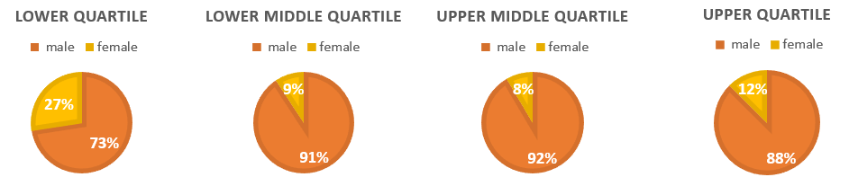
When comparing the 2021 figures to 2020, it shows that female representation has increased slightly in the upper quartile, and reduced slightly in the lower quartile, and this has contributed to reduction of the pay gap.

2021 Quartile | Male staff | Female Staff | 2020 Quartile | Male staff | Female Staff
Lower | 73% | 27% | Lower | 71% | 29%
Lower Middle | 91% | 9% | Lower Middle | 91% | 9%
Upper Middle | 92% | 8% | Upper Middle | 91% | 9%
Upper | 88% | 12% | Upper | 89% | 11%

However, when we compare the amount of women in the different quartiles as part of the total amount of women and do the same for men, it becomes clear that nearly half the women employed by the organisation, are in the lower quartile compared to only 21% of men.

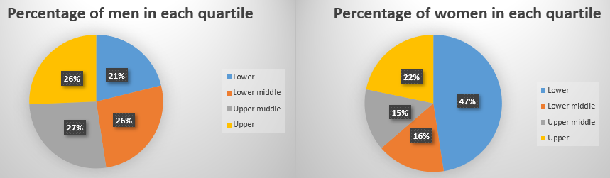

3.3 Key issues
The key issues identified affecting the current Gender Pay Gap are:
- Female staff are under-represented in senior roles (Area Manager and Grade 10 or above) and representation has decreased in the Wholetime senior roles;
- Female representation has hardly changed in any of the quartiles;
- Female staff are under-represented in all uniformed roles other than in Control;
- Female staff are under-represented in all quartiles due to the low percentage of women in the overall workforce.
- The female representation in the On Call workforce decreased from 71 to 68 and all new starters in this group will be in the lower quartiles.
- Female staff were disproportionately affected with regard to being excluded from the calculations as only 57% were included in the calculations compared to 78% of the male staff.
- The majority of Green Book posts in the lowest two grades are held by female staff and the majority of the career progression posts, which start in the lower grades, are held by men;
- Both all staff and wholetime gender pay gaps are above the national averages for all employees and fulltime employees.
- Occupational segregation remains a feature of the Fire and Rescue sector
Noteworthy:
- DSFRS Pay Gap is slightly less than half of the national pay gap.
- Although the coronavirus (COVID-19) has had a substantial impact on labour market hours worked and pay, it appears to have had little impact on the Service’s gender pay gap due to pay protection of our staff and avoidance of furlough.

4. Where is the Gap coming from?

4.1 General factors influencing an organisational Gender Pay Gap
Various factors, including occupational segregation, flexible working and discrimination (Equal Pay), impact on the Gender Pay Gap within organisations nationwide and the impact of each factor depends on the nature of the organisation.

From a Fire & Rescue Service (FRS) context, historically the public perception is that the role of a Fire-fighter is mainly more suited to men. Although this is incorrect, the result is that the FRS is largely a male-dominated sector and therefore traditionally it has been a struggle for FRSs to recruit women and people from minority groups. Although FRSs are doing a lot of work educating the public to change this perception, regretfully progress is slow.

4.2 Equal Pay
The Service is committed to achieving a diverse workforce. Providing equal pay for equal work is central to the concept of rewarding people fairly for what they do. The Service is confident that it is paying the same salary for equivalent roles. Determining the pay of Service employees is done through national collective bargaining for all staff.

The Service’s pay system covers Green Book, Grey Book and Gold Book grades/roles and pay scales. The Green Book grades range from administrative to managerial level (scale point 1-55). Grey Book roles include Firefighter to Area Manager. Gold Book covers the roles above Area Manager. The level of responsibility varies between different roles and all roles have been evaluated to determine the appropriate pay grade.

Each Green Book grade has a set pay range with pay increments in between grades. Staff are expected to move through the scale points associated with their role until they reach the maximum scale point for the role. Consequently, the longer someone has been in a role the more they will earn (subject to the maximum scale point) irrespective of their gender. All pay grades have a maximum of 4 scale points to reduce the amount of time to reach the top of the grade.

The Service is therefore confident that the identified gender pay gap does not stem from paying males and females differently for the same or equivalent work i.e. discrimination. Rather, it is a result of the roles in which males and females work within the Service and the salaries these roles attract. This is known as occupational segregation (see paragraph 4.3).

The Service carries out regular Equal Pay Audits. The most recent report is based on data from 31 March 2017, but the relevant data is produced every year for the same date as the gender pay gap calculations. This data informs part of the content of this report.

4.3 Occupational Segregation in the Service

Occupational segregation is defined as the distribution of workers across and within occupations, based upon demographic characteristics, most often gender, age and ethnic background.

The National Office of Statistics explains that the clearest insight into the gender pay gap is provided by analysis across age groups. For age groups under 40 years, the gender pay gap for full-time employees is low, at 3% or below. This has been the case since 2017.

However, for age groups 40 to 49 years and older, the gender pay gap for full-time employees is much higher, at approximately 12%. Their 2019 analysis explored the types of occupation that men and women work in, by age group. In particular, it flagged a lower incidence of women moving into higher-paid managerial occupations after the age of 39 years, at which point pay in these occupations increases. This means that women over 40 years are more likely to work in lower-paid occupations and, compared with younger women, are less likely to work as managers, directors or senior officials.

The nature of occupations in the Service, and as a result the male/female distribution, varies between staff groups and this is explained below. No age data has been extracted and analysed to establish whether the national trends are reflected within the Service.

Wholetime
This uniformed element of the workforce of the Service consisted mainly of male staff who occupy 92.9% of roles. This percentage has slightly reduced in the last couple of years. Of the 6.4% female Wholetime staff, 1 occupied higher paid roles i.e. Group Manager and above, compared to 31 male staff.

Wholetime | Male staff | Female staff | Gap £ | 2021 Gap % | 2020 Gap %
Mean hourly rate | £18.19 | £16.49 | £1.70 | 9.3% | 4.6%
Median hourly rate | £16.16 | £14.79 | £1.37 | 8.5% | 9.2%

In 2021, the gap among full-time employees was 7.9%, up from 7.0% in 2020. This is still below the gap of 9.0% before the coronavirus (COVID-19) pandemic in 2019, and so the downward trend is continuing. - Office for National Statistics (ONS) 26/10/21.

The percentage of female staff who were at Firefighter level proportionately to the gender group, was 67% compared to 50% of male staff. There were proportionately fewer female than male staff at Crew Manager, Watch Manager and Group Manager level, but a higher percentage of 11% at Station Manager level (4 of the 36 Wholetime women and 38 of the 524 men).

As many allowances are linked to roles of Watch Manager and above, many female staff did not receive them as part of their terms & conditions, which reduced their average hourly rate in comparison to their male colleagues.

The most senior roles occupied by a woman is Group Manager. Last year the highest role was Area Manager. This affects the gap in a negative way.

On Call

On Call | Male staff | Female staff | Gap £ | 2021 Gap % | 2020 Gap %
Mean hourly rate | £15.47 | £14.29 | £1.18 | 9.2% | 6.1%
Median hourly rate | £16.04 | £14.99 | £1.05 | 6.5% | 7.0%

Within the On Call male staff group (1073), 7% were Watch Managers, 17% were Crew Managers and 75% were Firefighters. Of the 68 female staff, 1% was Watch Manager, 7% were Crew Managers and 91% were Firefighters. The female representation in the On Call workforce decreased from 71 to 68.
There are 3 role levels within the On Call staff group (Wholetime has 8 role levels), which limits the difference between pay for the highest role and the lowest role. However, differences in activity levels relating to incidents of varying stations can result in big differences between staff. Allowances paid in this duty system often relate to additional responsibilities and are available to all roles.

As a result of these differences in relation to the Wholetime terms & conditions, the Median Gender Pay Gap within the On Call staff group is less than within the Wholetime Group.

It should be noted that the methodology to calculate the Pay Gap has resulted in some female and male staff being excluded for one of 3 reasons; the first being that they are staff from one of the stations that are paid a salary based on historic levels of emergency incidents. The second that they are staff who were not employed for the whole of January-March 2021 or were on unpaid leave or maternity leave in the reference period and the third that they are staff whose derived “annualised” hours were less than 104, i.e. minimum annual hours for On-call staff.

As a result of the above, only 837 male staff and 39 female staff were included in the calculations whilst 1073 men and 68 women were employed by the Service at the time of extraction of the data and calculating the pay gap.

Female staff were disproportionately affected as only 57% were included in the calculations compared to 78% of the male staff. Although the female contingent decreased by 3, the amount of women included in the calculations decreased by 6.

The low percentage of female staff in the uniformed part of the workforce is a matter of national attention. In November 2021, Lord Greenhalgh, Minister of State for Building Safety and Fire, once again reminded the sector that we must attract a greater diversity of talented people and reflect better the communities that we serve. We want and need to see more female firefighters and more firefighters from ethnic minorities.

Research shows that many women in the community don’t consider joining the uniformed fire & rescue service for various reasons, including that it is a male-dominated environment and a perception that the work is too physical or too dangerous.

Control

Control | Male staff | Female staff | Gap £ | 2021 Gap % | 2020 Gap %
Mean hourly rate | £14.83 | £14.78 | £0.05 | 0.3% | 7.9%
Median hourly rate | £15.40 | £14.03 | £1.37 | 8.9% | 9.7%

There is less segregation in what is generally perceived as “men’s work versus women’s work” within the Green Book and Control staff groups where the roles are, in the main, more office based. This is reflected in the percentages of male and female staff in those roles, i.e. 46% of Green Book staff and 70% of Control staff were female.

There were no male staff in the highest grade in Control with 1 female Station Manager. Compared to the overall ratio of female to male staff in control, there were proportionately fewer female (7%) than male (42%) Watch Managers. This is reversed for Crew Managers (17% ♂ vs 25% ♀) and Firefighters (42% ♂ vs 64% ♀). The latter is a change from 2020 when there was a bigger ‘in gender’ percentage Crew Managers for men. Considering the small amount of staff working in Control (40), this shift at Crew Manager Level has had a considerable impact on the gender pay gap.

Although only 1 in 3 members of staff in Control are male (30%), 5 out of 7 Watch Manager positions are occupied by male staff (71%). This appears to support the theory that women, for various reasons, are less likely to progress to leadership positions.

The higher roles in Control (Station and Group Manager), as with the Wholetime staff group, also attract flexibility allowances. As there were no male staff in those roles, this affects the pay gap in this staff group positively towards female staff.

Green Book staff

Green Book | Male staff | Female staff | Gap £ | 2021 Gap % | 2020 Gap %
Mean hourly rate | £17.57 | £16.02 | £1.55 | 8.8% | 10.0%
Median hourly rate | £16.24 | £14.37 | £1.87 | 11.5% | 8.6%

Overall there were 164 female staff in Green Book (Support, non-uniformed) roles and 191 male staff. Whilst female staff were well represented amongst this staff group, there were many more female than male staff in the most junior posts, grades 2 and 3, with most of the female staff in clerical or administrative posts and most of the male staff in caretaking or technician roles. Only around 8% of male staff are in grades 2 and 3, whilst this percentage is around 30% for female staff.

There is a fairly good gender balance in the middle management grades 4, 6, 7 and grade 9 and 11. Grade 5 and senior management grades 8 and 10 have significantly more male than female staff. It is noteworthy that the male representation in career progression roles, i.e. roles where a person through development can increase grade from 3 to 5 or as high as 7, is significantly higher with about 80% of those positions being occupied by men.

The above can also be seen in the male/female distribution in the pay quartiles of Green Book staff.

Figure 2 Male/female distribution in the pay quartiles of Green Book staff

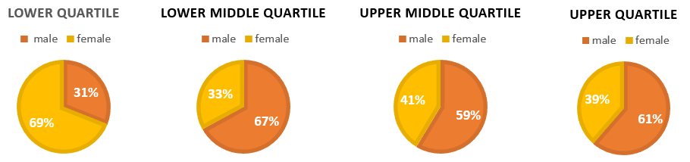

In this category, 5 women were not included in the calculations. This is a likely result of pregnancy or maternity leave. No men were excluded.

Casual Workers

Casual | Male staff | Female staff | Gap £ | 2021 Gap % | 2020 Gap %
Mean hourly rate | £17.13 | £13.63 | £3.50 | 20.4% | 6.8%
Median hourly rate | £16.26 | £14.65 | £1.61 | 9.9% | 6.2%

There has again been a significant decrease in the amount of Casual workers from 88 to 35, and this has also changed the percentage of men to women in casual employment, 77% and 23% respectively.

Casual workers are involved in Community Fire Safety work, which includes general community activities (Advocates) and working with Children and Young Persons (CYP worker). A smaller group consists of individuals who support the training function of the Service’s Training Academy or provide general administrative support.

Male/female distribution within the casual worker’s roles

 | 2021 | 2021 | 2021 | 2020 | 2020 | 2020
 | Total | ♀ % | ♂ % | Total | ♀ % | ♂ %
Advocate | 5 | 60% | 40% | 21 | 38% | 62%
CYP | 14 | 21% | 79% | 33 | 36% | 64%
Casual (Support) | 5 | 40% | 60% | 10 | 60% | 40%
Casual (Uniformed) | 11 | 0% | 100% | 24 | 4% | 96%

The Advocates have the lowest average hourly pay and the Training Academy Casuals the highest. This results in the lower quartiles consisting of Advocates and CYP individuals. The Upper 2 quartiles consist mostly of male staff and they mainly undertake Academy Casual work. The difference of pay between the lower 2 quartiles and the upper 2 due to the role split, explains the resulting gender pay gap.

Figure 3 Distribution of male/female casual workers in pay quartiles

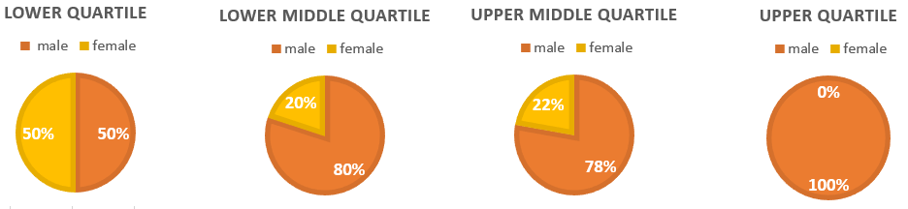

Conclusion about the effect of occupational segregation on the gender pay gap

Although the Gender Pay Gap calculations demonstrate occupational segregation, they are not able to identify whether there is a ‘glass ceiling’ (a metaphor used to represent an invisible barrier that keeps a given demographic from rising beyond a certain level in a hierarchy) within any organisation or within any individual staff group.

As with most companies in Britain, the number of women holding the most senior jobs in the boardroom of the Service (1 of 6 positions in the Executive Board) has barely changed in the past 10 years, despite a series of government-backed initiatives to boost gender diversity.

4.4 Flexible working in the Service

The Service is committed to ensuring that every employee, each with their own family commitments and personal aspirations, is facilitated in achieving a work life balance, and recognises that employees perform best and achieve the highest standards when this is so. Solutions to improve or maintain employees’ work-life balance should be achieved through discussion and agreement between employees and managers and will often have benefits to both individuals and the Service.

The Service has recently reviewed the Flexible Working policy and a Family Leave policies, which outline a number of options in relation to flexible working. It is recognised, however, that one size does not fit all and managers and employees are asked to look at creative solutions to balance Service requirements with those of the individual, taking account of fairness and consistency in approach.

The pandemic led to changing circumstances in relation to the amount of employees working more agile and flexible, especially among the Green Book staff group. This has not led to changes in employee’s pay as those who could not work were pay protected and others continued their job from home.

Across the Service, 42% of male staff were part-time (most being On Call firefighters providing part cover) and 44% of female staff (most in Green Book roles). In all categories the proportion of female part-time workers was higher than male with the Wholetime having the smallest difference (male 3%, female 11%), then Green book staff (male 38%, female 23%) and On Call with the biggest difference (male 65%, female 81%). There were no part-time male staff in Control and 8% of the female staff worked part time.

5 Ethnicity Pay Gap

Since introduction of the gender pay gap there have been ideas around introducing similar calculations for ethnicity pay gaps. The Office of National Statistics (ONS) has done the calculations on a national level to allow for some benchmarking.
There are no regulations around ethnicity pay gap calculations and any pay gap reporting other than gender is completely voluntary. Methods of calculations may differ between organisations as there are no guidelines available. However, the Service has committed to calculating the ethnicity pay gap where possible. It is calculated as the difference between the median hourly earnings of the reference group (White or White British) and other ethnic groups as a proportion of average hourly earnings of the reference group.

5.1 Methodology

Not taking into account the 5.0% of individuals who have chosen not to state their ethnic background, currently the Service’s workforce consists of 2.7% ethnic minority staff. The Control staff group is most diverse with regards to minority ethnic representation with 7.5% and 0% ‘not stated’. The Support Staff group is the next highest with 4.0%, but with ‘not stated’ of 5.9%.

Excluding all ‘white’ groups, the representation of People of Colour (Black, Asian, mixed, other) in the Service is 0.8%. The community percentage in most areas is 1.5-2.5%, but more in urban areas (Exeter 7%, Plymouth 3.8%). In the Southwest as a whole, that percentage is 4.6%.

Ethnic minority background in this context includes individuals who are White but have other backgrounds than British e.g. South African or EU nationals. In the ethnicity pay gap calculations, White is treated as one group irrespective of their country of origin. This results in very few staff (16) being included in this group, especially compared to the size of the group of individuals who ‘did not state’ or ‘prefer not to say’ (105).

Individuals may end up recording as ‘did not state’ or ‘prefer not to say’ group due to restrictive ethnic background categories. These restrictive, but generally accepted, categories could result in individuals not identifying with a particular one as they don’t want to identify with any or they can’t find the one they do want to identify with. A certain proportion of staff doesn’t want to self-identify for one reason or another.

Together with other White groups (which include Gypsy & Traveller, Irish and ‘Other White’) there are 56 individuals who could be considered to have an ethic minority background in the Service, but for these calculations only those who identified as other than White have been included. This may need to be reconsidered as not only skin colour, but also English as a second language, recognition of foreign qualifications or certain cultural aspects can have an effect on career prospects in the UK.

Breaking the Non-White group down into specific ethnic backgrounds leads to group sizes with less than 5 people. The Service has decided that this would not be statistically relevant and it could identify individuals. This would not be adhering to data protection legislation. Therefore, only White/ People of Colour and White/Mixed figures will be quoted.

5.2 Ethnicity Pay Gap within the Service

Ethnicity Pay gap
Mean hourly rate of pay for White people: | £16.65 | Median hourly rate of pay for White people: | £16.07
White/ People of Colour (Black, Asian, Mixed, other)
Mean hourly rate of pay for People of Colour: | £15.14 | Median hourly rate of pay for People of Colour: | £14.79
Mean White/ People of Colour pay gap: | 9.1% | Median White/ People of Colour pay gap: | 8.0%
White/ Mixed background
Mean hourly rate of pay for Mixed: | £14.76 | Median hourly rate of pay for Mixed: | £14.63
Mean White/Mixed pay gap: | 11.4% | Median White/Mixed pay gap: | 9.0%

Compared to 2020, the first year the Service reported the ethnicity pay gap, both the mean and median pay gaps have decreased, 9.1% now down from 11.3% in 2020 and 11.4% now down from 14.8% respectively. The Office of National Statistics reports that, in 2019, the median hourly pay for those in the White ethnic group nationally was £12.40 per hour compared with those in ethnic minority at £12.11 per hour – a pay gap of 2.3%. In the Southwest the pay gap was 6.1%.

Individuals in the People of Colour group are distributed reasonably evenly among the 3 top quartiles (0.5-0.9%), but there are nearly twice as many in the lowest quartile (1.6%).

Figure 4 Distribution of white/people of colour staff in pay quartiles 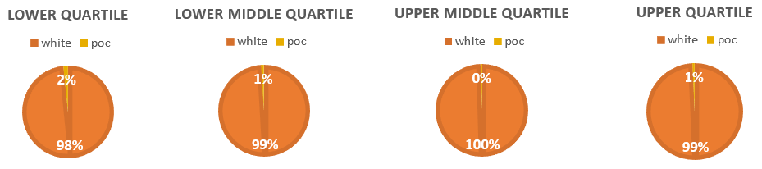
The distribution of People of Colour in the quartiles compared to the whole group of People of Colour in the Service, shows a similar distribution as for women.

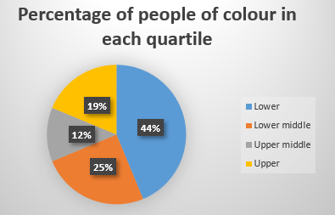

5.3 Where does the ethnicity pay gap in the Service come from?

The simple comparison between White and ethnic minority groups does mask a wide variety of experiences among different ethnic minorities and is not necessarily or solely a result of discrimination or racism.

The pay someone earns depends on multiple different factors, such as their occupation or location. Although not a factor within the Service pay gap, the pay someone receives differs by where in England and Wales they lived.

If pay determining characteristics vary between ethnic groups, the pay gaps observed might result from differences in these characteristics, rather than because of ethnicity.

The highest qualifications an employee has gained is a factor in the pay received. Those with a higher level of qualifications tend to have higher levels of pay (nearly half of those with a degree are in the top 25% of the pay distribution). Keeping all other factors constant, having a degree increases the pay on average by 18% compared with those with a GCSE, and 13% with those with an A Level. This would mean that certain ethnic groups, who are more likely to have a degree, would see a smaller pay gap. Those ethnic groups, including Indian, Arab and Chinese, have not been calculated for the Service due to small numbers.

Age also affects the level of pay received. On average pay increases by 3% for each year older an employee is, which means that if the ethnic groups have different age profiles we might expect different median earnings levels. For example, nationally, those in the White and Black Caribbean ethnic group had a median age of 30 years old, compared with 41 years old for White British employees. Due to low numbers of non-White staff in the Service it is not possible to evidence whether this characteristic influences the Service’s pay gap.

Looking across the regions and ethnic groups nationally, ONS notes that pay gaps tend to be wider for those who were born outside of the UK compared with those who are UK born. This is particularly the case for those in the Asian and Other ethnic groups, whereas the difference for those in the Black ethnic group is more modest. The Service does not record data about where staff were born, so it is not possible to identify the impact of this characteristic.

As most of the above factors are not possible to identify due to the small amount of non-white or ethnic minority staff within the Service, the pay gap within the organisation can only be explained by that fact and the roles those few staff have.

Therefore, the gap is mainly impacted by:
- In the Green Book group, people of colour are only in middle management roles (grades 4-9). This is different from 2020 when there were 2 staff in roles with the lowest pay out of all groups.
- In the groups which most affect the pay gap in the Service, i.e. Wholetime and On Call, 90% of people of colour are at Firefighter level.
- All people of colour in the Control staff group are at Firefighter level.

Considering numbers of staff included in the calculation and distribution in the organisation and quartiles, it is likely that the reduction in the pay gap is a result of the pay scheme changes in the On Call group and no more people of colour in the lowest paid grades.

6 Working towards reducing the Gender Pay Gap

Reducing the gender pay gap in the Service is beneficial for employees and the community we serve. Research shows that a more diverse and inclusive workforce helps organisations develop by bringing new skills, creativity and innovation, better decision-making and higher staff satisfaction and retention. These benefits will apply to Devon and Somerset Fire and Rescue Service.

In the UK today, female workers earn on average 15% less than male workers. The gender pay gap exists because female workers, especially over the age of 40, tend to have lower-paid occupations and sectors, and occupy less senior roles. This is reflected in the Service’s data. Many female workers take time out of the labour market and work part-time because of unequal sharing of care responsibilities. Unconscious bias, including stereotypes, barriers due to policies/processes and workplace culture are also factors which the Service acknowledges and aims to address where they exist.

The Service is taking short, medium and long-term approaches to achieving a more diverse workforce in order to improve the way we deliver services to the community of Devon & Somerset. Whilst we have improved in this area, we know that we can do more and recognise that patterns of under-representation and differences in outcomes can be challenged through positive action programmes. Notwithstanding national drivers, the diversity of skills, knowledge, perspectives and experiences within the workforce will ensure we will be better placed to identify and meet the needs of our community.

The Service has a People Strategy, which has areas of focus for all departments and supports the aims the Service has set in the Fire and Rescue Plan.
Work is being started or continuing on:
• Implementation of a new service delivery model to improve response availability, including contracts which can provide greater flexibility in working patterns and hours and are more attractive to a wider range of people, especially those with caring responsibilities
• Aligning departmental objectives with our People Strategy, which defines who we aim to be, and Workforce Plan to show how we resource our new ways of working
• Undertaking People Impact Assessments for changing processes and practices. This requires input from and identifies impacts on underrepresented groups including women at an early stage
• Delivering management development, some specific to women in management positions, within our leadership framework
• Implementing a recruitment process that focuses on recruiting the skills we need for the future and remove barriers to increasing diversity and inclusion in our workforce through positive action and reducing bias within the process
• Introducing schemes for alternative career paths and different ways of learning
• Broadening apprenticeship opportunities for new and existing staff to develop their careers

Further actions to reduce the Gender Pay Gap and increase diversity within the workforce will be developed through the Service’s People Strategy & Inclusion monitoring Group and Strategic Workforce Planning Board and captured in a new People Strategy from 2022.

References
Government Equality Office - Eight ways to understand your organisation’s gender pay gap
Government Equality Office - Reducing the gender pay gap and improving gender equality in organisations: Evidence-based actions for employers
Government Equality Office - Women’s Progression in the Workplace
Government Equality Office - Gender equality at every stage: a roadmap for change
CIPD - Gender pay gap reporting
EHRC – Closing the Gender Pay Gap
Office of National Statistics – Ethnicity pay gaps 2019

Appendix – Figures, tables and charts

Gender pay gap

All Staff | Male staff | Female staff | Gap £ | Gap %
Mean hourly rate | £16.78 | £15.64 | £1.14 | 6.8%
Median hourly rate | £16.07 | £14.76 | £1.31 | 8.2%

Wholetime | Male staff | Female staff | Gap £ | 2021 Gap % | 2020 Gap %
Mean hourly rate | £18.19 | £16.49 | £1.70 | 9.3% | 4.6%
Median hourly rate | £16.16 | £14.79 | £1.37 | 8.5% | 9.2%

On Call | Male staff | Female staff | Gap £ | 2021 Gap % | 2020 Gap %
Mean hourly rate | £15.47 | £14.29 | £1.18 | 9.2% | 6.1%
Median hourly rate | £16.04 | £14.99 | £1.05 | 6.5% | 7.0%

Control | Male staff | Female staff | Gap £ | 2021 Gap % | 2020 Gap %
Mean hourly rate | £14.83 | £14.78 | £0.05 | 0.3% | 7.9%
Median hourly rate | £15.40 | £14.03 | £1.37 | 8.9% | 9.7%

Green Book | Male staff | Female staff | Gap £ | 2021 Gap % | 2020 Gap %
Mean hourly rate | £17.57 | £16.02 | £1.55 | 8.8% | 10.0%
Median hourly rate | £16.24 | £14.37 | £1.87 | 11.5% | 8.6%

Casual | Male staff | Female staff | Gap £ | 2021 Gap % | 2020 Gap %
Mean hourly rate | £17.13 | £13.63 | £3.50 | 20.4% | 6.8%
Median hourly rate | £16.26 | £14.65 | £1.61 | 9.9% | 6.2%

Gender pay gap Quartiles

2021 Quartile | Male staff | Female Staff | 2020 Quartile | Male staff | Female Staff
Lower | 73% | 27% | Lower | 71% | 29%
Lower Middle | 91% | 9% | Lower Middle | 91% | 9%
Upper Middle | 92% | 8% | Upper Middle | 91% | 9%
Upper | 88% | 12% | Upper | 89% | 11%

All staff

Green Book

Casual workers

Ethnicity Pay Gap

Ethnicity Pay gap
Mean hourly rate of pay for White people: | £16.65 | Median hourly rate of pay for White people: | £16.07
White/ People of Colour (Black, Asian, Mixed, other)
Mean hourly rate of pay for People of Colour: | £15.14 | Median hourly rate of pay for People of Colour: | £14.79
Mean White/ People of Colour pay gap: | 9.1% | Median White/ People of Colour pay gap: | 8.0%
White/ Mixed background
Mean hourly rate of pay for Mixed: | £14.76 | Median hourly rate of pay for Mixed: | £14.63
Mean White/Mixed pay gap: | 11.4% | Median White/Mixed pay gap: | 9.0%

Ethnicity pay gap Quartiles

